**TABLE OF CONTENTS**

|  |  |  |
| --- | --- | --- |
| SR. No. | DESCRIPTION | PAGE NO. |
| 1. | PREFACE | 2 |
| 2. | DECLARATION | 3 |
| 3. | ACKNOWLEDGEMENT | 4 |
| 4. | CERTIFICATE | 5 |
| 5. | COMPANY’S PROFILE | 6-7 |
| 6. | INTRODUCTION TO TECHNOLOGY USED IN PROJECT | 7-23 |
| 7. | INTRODUCTION TO PROJECT | 24-34 |
| 8. | DATABASE DESIGN | 35-39 |
| 9. | SCREENSHOTS | 40-51 |
| 10. | FUTURE SCOPE | 52 |
| 11. | CONCLUSION | 53 |
| 12. | BIBLIOGRAPHY | 54 |

**PREFACE**

“**Punjab Police Digital Portal**” is a Desktop Application made in Java consisting of various modules and features to overcome current problems in the system of filing reports , keeping track of records, Changing the records and all the other tasks, which are currently done with Pen And Paper , can be done with this application without much effort in maintaining them.

The main basic modules which form the base of PPDP are :-

* Admin Module.
* Change Password Module.
* Senior Citizen Registration Module.
* Missing Person’s Report Module.
* Stolen Vehicle Report Module.
* Stolen Mobile Report Module.
* Add Criminal Records Module.
* View Records Module.
* Search and Sort Records Module.
* Print Report Module.
* Wanted Criminal Module.
* Edit Criminal Records Module.

PPDP can Only Be accessed with admin ID and Password and there is no other way to access it. That ensures security as well as responsibility of the admin over all the actions. The admin can change the password if he wants to after he’s logged in to HomeScreen of PPDP.

PPDP uses JDK for its frontend and MySQL as its database at backend.

Once logged in, adding the records is much easier since there are predefined columns for every report and registration. The admin just need to fill the columns and click submit and it’s done.

Viewing and analyzing the records is most crucial task and also the most time consuming too. But with this app viewing and searching the records becomes a piece of cake. And with the feature of sorting the records saves a lot of time and that cannot be done easily with the registers etc.

Since every module is accessed from HomeScreen, it becomes a lot easier to do all the tasks from just one place. All the modules are self-describing and the person using the app for the first time can easily access the app without requiring much training or experience in the field of computer science.

**DECLARATION**

I hereby declare that the project work entitled “**Punjab Police Digital Portal**” is an authentic record of my own work carried out at SOLITAIRE INFOSYS, Patiala as requirements of project semester training for the award of degree of B.Tech. (Computer Science), under the guidance of Ms. during 5 June toJuly, 2017.

(Signature of student)

Date: ___________________

Certified that the above statement made by the student is correct to the best of our knowledge and belief.

**Ms. Kanchan**

(Technical Head)

Industry coordinator

**ACKNOWLEGDEMENT**

I am highly grateful to the, HOD Department of Computer Science Engineering, UCoE Punjabi University Patiala for providing this opportunity to carry out the six weeks industrial training at SOLITAIRE INFOSYS.

I would like to expresses my gratitude to other faculty members of Computer Science department for providing academic inputs, guidance & encouragement throughout the training period.

I would like to express a deep sense of gratitude and thank Mr. JogvinderSingh, Director/CEO of Company, without whose permission, wise counsel and able guidance, it would have not been possible to pursue my training in this manner.

The help rendered by Ms. Kanchan for experimentation is greatly acknowledged.

Finally, I express my indebtedness to all who have directly or indirectly contributed to the successful completion of my industrial training.

Ishwer Kumar

**CERTIFICATE**

**COMPANY’S PROFILE**

**AN OVERVIEW**

SOLITAIRE INFOSYS is a leading Software and Web Application Development Company, based in Mohali (Chandigarh) that provides high quality comprehensive services to enterprises across a wide range of platforms and technologies. Our major areas of expertise are in providing quality, cost effective software or web development.

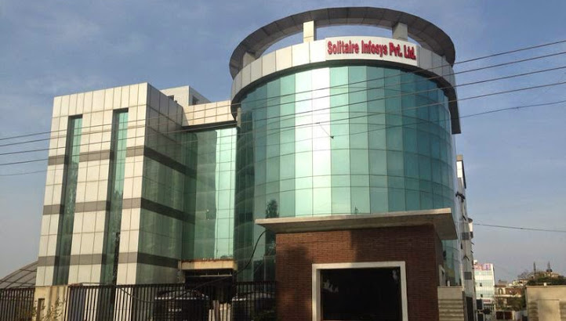



**Focus of the Company**

The Company focuses on understanding the diverse and mission-critical needs of each of our clients. To understand is to be able to deliver. The competence and experience of our company gives us a competitive edge by making sure we provide the best services and products to our clients. Our high-quality standards enable us to deliver reliable and error-free software applications, despite their complexity.

The Company provides Web design/Web development, B2B & B2C E-commerce solutions, SEO & Web Promotions strategies implementation consulting services to both domestic as well as international clients at the most affordable rates.

**Operating excellence**

* A safe, fun and professional work environment
* Good relationships with industry and other partners
* Respect for the rights and ambitions of our employees
* Honorable, value-driven business relations

**HISTORY OF THE COMPANY**

Solitaire Infosys Inc. was a dream came into existence over three years ago with a strong aspiration of becoming a best IT service provider around the globe. Presently, Solitaire Infosys is already leading the race with its competitors. Being nurtured by a team of experienced and sensitive people.We try to bond emotionally with our clients and love to go an extra mile to satisfy their needs, which is the reason that we hold the edge in the league.

At Solitaire Infosys Inc. we provide the experience, expertise and capabilities that enable organizations to accelerate their service processes, deliver more service value and realize breakthrough results in the markets they serve. Now our clients not only appreciate our comprehensive range of services, our innovative, streamlined and cost effective solutions, but more importantly, they appreciate our high level of excellent customer service which is unparalleled in the industry.

**INTRODUCTION TO TECHNOLOGY USED IN PROJECT**

1. **PLATFORM- JAVA and JDK 1.7**
   1. **JAVA**

Java is a programming language developed by Sun Microsystems. It implements a strong security model, which prevents compiled Java programs from illicitly accessing resources on the system where they execute or on the network popular World Wide Web and other browsers as well as some World Wide Web servers and other system implement Java interpreters These are used to display interactive user interfaces, and to script behavior on these systems While implementation problems have opened security vulnerabilities in some java interpreters (Java virtual Machines or JVM'S),the design of this language makes it at least theoretically possible to execute program with reasonable assurances about its Security, and in particular its ability to cause harm.

An editor of the java platform is the name for a bundle of related program from sun which allow for and running program written in the java programming language. The platform is not specific to any one processor or operating system, but rather an execution engine (called a virtual machine and a complier with a set of libraries that are implemented for various hardware and operating system so that java program can run identically on all of them.

**Characteristics of Java**

* Java is platform independent.
* Java is robust and secure.
* Java is object oriented.
* Multi-Threaded.
* Java is dynamic.
* High performance.
* Java is portable.

The java Platform consists of several program, each of which provides a distinct portion of its overall capabilities. For example, the java complier, which converts java source code into java bytecode (an intermediate language for the Java Virtual Machine (JVM)) is provided as part of the Java Development Kit (JDK). The Java Runtime Environment(JRM), complementing the JVM with a just-in-time(JIT)complier, coverts intermediate byte code into native machine code on the fly. Also supplied are extensivelibraries, pre-compiled in which are several other components, some available only in certain editions.

* 1. **JDK 1.7**

The Java Development Kit(JDK) is an implementation of either one of the Java SE, Java EE or Java ME platforms released by Oracle Corporation in the form of the binary product aimed at Java developers on Solaris, Linux, Mac OS X or Windows. The JDK includes a private JVM and a few other resources to finish the recipe to a java application. On 17 November 2006 Sun announced that it would be released under the GNU General Public License (GPL), thus making it free software.

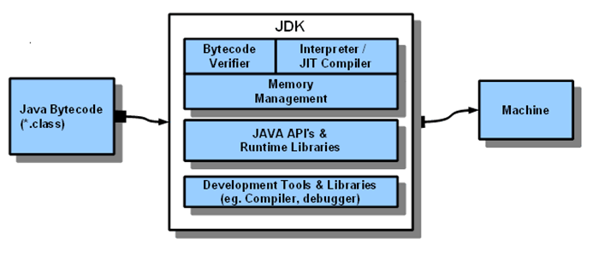

* 1. **JVM and JRE**

The JDK also comes with a complete Java Runtime Environment, usually called a private runtime, due to the fact that it is separated from the regular JRE and has extra contents. It consists of a Java Virtual Machine and all of the class libraries present in the production environment, as well as additional libraries useful to developers such as the internationalization libraries and the IDL libraries.

* 1. **JDK TOOLS**
* Compiler
* The Runtime Interpreter
* Applet Viewer
* Debugger
* Class File Disassembler
* Header and Stub File Generator
* Documentation Generator

1. **NETBEANS**NETBEANS is an integrated development environment (IDE) for developing primarily with JAVA, but also with other languages, in particular PHP, C/C++, and HTML5.It is also an application platform framework for java desktop applications and others.

The NetBeans IDE is written in java and can run on window-shops, Linux, Solaris and other platforms supporting a compatible JVM.

The NetBeans platform allows applications to be developed from a set of modular software components called modules. Applications based on the NetBeans platform can be extended y third party developers.

The net beans team actively support the product and seek feature suggestions from the wider community. Every release is preceded by a time for community testing and feedback.

The basic versions used are:

NetBeans IDE 6.9, released in june2010, added support for OSGi, Spring Framework 3.0, Java EE dependency injection (JSR 299), Zend Framework for PHP and easier code navigation (such as “Is Overridden/implemented” annotations), formatting, hints, and refactoring across several languages.

NetBeans IDE 7.0 was released in April 2011.On August1, 2011 the NetBeans Team released NetBeans IDE7.0.1 which has full support for the official release of the JAVA SE 7 platform.

**Technologies:**

The term Ajax has come to represent a broad group of Web technologies that can be used to implement a Web application that communicates with a server in the background, without interfering with the current state of the page. In the article that coined the term Ajax,[3] Jesse James Garrett explained that the following technologies are incorporated:

* HTML (or XHTML) and CSS for presentation
* The Document Object Model (DOM) for dynamic display of and interaction with data
* XML for the interchange of data, and XSLT for its manipulation
* The XMLHttpRequest object for asynchronous communication
* JavaScript to bring these technologies together

1. **MySQL**



MySQL is a fast, easy-to-use RDBMS being used for many small and big businesses. MySQL is developed, marketed, and supported by MySQL AB, which is a Swedish company. MySQL is becoming so popular because of many good reasons:

* MySQL is released under an open-source license. So you have nothing to pay to use it.
* MySQL is a very powerful program in its own right. It handles a large subset of the functionality of the most expensive and powerful database packages.
* MySQL uses a standard form of the well-known SQL data language.
* MySQL works on many operating systems and with many languages including PHP, PERL, C, C++, JAVA, etc.
* MySQL works very quickly and works well even with large data sets.
* MySQL is very friendly to PHP, the most appreciated language for web development.
* MySQL supports large databases, up to 50 million rows or more in a table. The default file size limit for a table is 4GB, but you can increase this (if your operating system can handle it) to a theoretical limit of 8 million terabytes (TB).
* MySQL is customizable. The open-source GPL license allows programmers to modify the MySQL software to fit their own specific environments.

**Features of MySQL Database Software:**

* Internals and Portability:
* Written in C and C++.
* Tested with a broad range of different compilers.
* Works on many different platforms.
* Uses GNU Automake, Autoconf, and Libtool for portability.
* APIs for C, C++, Eiffel, Java, Perl, PHP, Python, Ruby, and Tcl are available.
* Fully multi-threaded using kernel threads. It can easily use multiple CPUs if they are available.
* Provides transactional and non-transactional storage engines.
* Uses very fast B-tree disk tables (MyISAM) with index compression.
* Relatively easy to add another storage engine. This is useful if you want to add an SQL interface to an in-house database.
* A very fast thread-based memory allocation system.
* Very fast joins using an optimized one-sweep multi-join.
* In-memory hash tables, which are used as temporary tables.
* SQL functions are implemented using a highly optimized class library and should be as fast as possible. Usually there is no memory allocation at all after query initialization.
* The MySQL code is tested with Purify (a commercial memory leakage detector) as well as with Valgrind, a GPL tool
* The server is available as a separate program for use in a client/server networked environment. It is also available as a library that can be embedded (linked) into standalone applications. Such applications can be used in isolation or in environments where no network is available.

**Security:** A privilege and password system that is very flexible and secure, and that allows host-based verification. Passwords are secure because all password traffic is encrypted when you connect to a server.

**Scalability and Limits**: Handles large databases. We use MySQL Server with databases that contain 50 million records. We also know of users who use MySQL Server with 60,000 tables and about 5,000,000,000 rows.

Up to 64 indexes per table are allowed (32 before MySQL 4.1.2). Each index may consist of 1 to 16 columns or parts of columns. The maximum index width is 1000 bytes (500 before MySQL 4.1.2). An index may use a prefix of a column for CHAR, VARCHAR, BLOB, or TEXT column types.

**Connectivity**: Clients can connect to the MySQL server using TCP/IP sockets on any platform. On Windows systems in the NT family (NT, 2000, XP, or 2003), clients can connect using named pipes. On Unix systems, clients can connect using Unix domain socket files.

In MySQL versions 4.1 and higher, Windows servers also support shared-memory connections if started with the --shared-memory option. Clients can connect through shared memory by using the --protocol=memory option.

The Connector/ODBC (MyODBC) interface provides MySQL support for client programs that use ODBC (Open Database Connectivity) connections. For example, you can use MS Access to connect to your MySQL server. Clients can be run on Windows or Unix. MyODBC source is available. All ODBC 2.5 functions are supported, as are many others.

The Connector/J interface provides MySQL support for Java client programs that use JDBC connections. Clients can be run on Windows or Unix. Connector/J source is available.

**Localization:** The server can provide error messages to clients in many languages.

Full support for several different character sets, including latin1 (ISO-8859-1), German, big5, ujis, and more. For example, the Scandinavian characters 'â', 'ä' and 'ö' are allowed in table and column names. Unicode support is available as of MySQL 4.1.

All data is saved in the chosen character set. All comparisons for normal string columns are case-insensitive.

Sorting is done according to the chosen character set (using Swedish collation by default). It is possible to change this when the MySQL server is started. To see an example of very advanced sorting, look at the Czech sorting code. MySQL Server supports many different character sets that can be specified at compile time and runtime.

**Clients and Tools**: The MySQL server has built-in support for SQL statements to check, optimize, and repair tables. These statements are available from the command line through the mysqlcheck client. MySQL also includes myisamchk, a very fast command-line utility for performing these operations on MyISAM tables.

All MySQL programs can be invoked with the “help” or “?”options to obtain online assistance.

1. **JDBC**

JDBC stands for **J**ava **D**ata**b**ase **C**onnectivity, which is a standard Java API for database-independent connectivity between the Java programming language and a wide range of databases.

The JDBC library includes APIs for each of the tasks mentioned below that are commonly associated with database usage.

* Making a connection to a database.
* Creating SQL or MySQL statements.
* Executing SQL or MySQL queries in the database.
* Viewing & Modifying the resulting records.

## JDBC Architecture

The JDBC API supports both two-tier and three-tier processing models for database access but in general, JDBC Architecture consists of two layers −

* JDBC API**:** This provides the application-to-JDBC Manager connection.
* JDBC Driver API**:** This supports the JDBC Manager-to-Driver Connection.

The JDBC API uses a driver manager and database-specific drivers to provide transparent connectivity to heterogeneous databases.

The JDBC driver manager ensures that the correct driver is used to access each data source. The driver manager is capable of supporting multiple concurrent drivers connected to multiple heterogeneous databases.

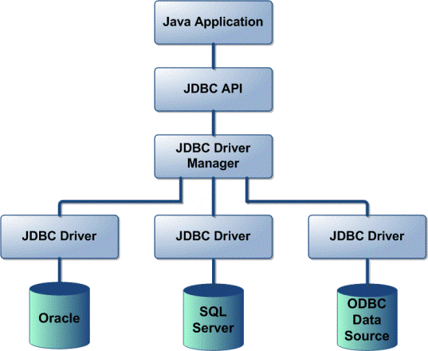

**JDBC Components:**

The JDBC API provides the following interfaces and classes :

* **Driver Manager:** This class manages a list of database drivers. Matches connection requests from the java application with the proper database driver using communication sub protocol. The first driver that recognizes a certain sub-protocol under JDBC will be used to establish a database Connection.
* **Driver:** This interface handles the communications with the database server. You will interact directly with Driver objects very rarely. Instead, you use DriverManager objects, which manages objects of this type. It also abstracts the details associated with working with Driver objects.
* **Connection:** This interface with all methods for contacting a database. The connection object represents communication context, i.e., all communication with database is through connection object only.
* **Statement:** You use objects created from this interface to submit the SQL statements to the database. Some derived interfaces accept parameters in addition to executing stored procedures.

**INTRODUCTION TO PROJECT**

“**Punjab Police Digital Portal**” is a Desktop Application made in Java consisting of various modules and features to overcome current problems in the system of filing reports , keeping track of records, Changing the records and all the other tasks, which are currently done with Pen And Paper , can be done with this application without much effort in maintaining them.

The main basic modules which form the base of PPDP are :-

* Admin Module.
* Change Password Module.
* Senior Citizen Registration Module.
* Missing Person’s Report Module.
* Stolen Vehicle Report Module.
* Stolen Mobile Report Module.
* Add Criminal Records Module.
* View Records Module.
* Search and Sort Records Module.
* Print Report Module.
* Wanted Criminal Module.
* Edit Criminal Records Module.

**OPERATION**

**Admin Module:** PPDP can only be accessed with Admin ID and Password and there is no other way to access it. That ensures security as well as responsibility of the Admin over all the actions. The Admin can change the password if he wants to after he’s logged in to HomeScreen of PPDP.

**Change Password Module:**Admin can change the password whenever he wants. But for that he needs to login with the old password first and then go to change password module. And also in change password module he needs to re-enter the current password before changing it. After the password is changed the admin is redirected to login frame.

**Registration and Report Modules:**These Include Senior Citizen Registration Module, Missing Person’s Report Module, Stolen Vehicle Report Module, Stolen Mobile Report Module. Once logged in, adding the records is much easier since there are predefined columns for every report and registration. The admin just need to fill the columns and click submit and it’s done.

**Records Module:**Viewing and analyzing the records is most crucial task and also the most time consuming too. But with this app viewing and searching the records becomes a piece of cake. And with the feature of sorting the records saves a lot of time and that cannot be done easily with the registers etc. Searching the Records can be done both by Name and Date of Incident. Sorting can be done by Name, by Date of Birth or by Date of Incident.

**Print Report Module:**This Is The Most Useful Module in which a copy of any report can be given to the person filing the report. Admin just need to enter the report or F.I.R. Number and that report will be given as a PDF file which can either be printed to Paper or Given as e-Copy of Report. The report number starts with PP**#. For Example, ‘PPVT001’ Indicates Punjab Police Vehicle Theft #001.

**Add/Edit Criminal Record Module:**In This Module, Criminal records are added to database along with pictures of them in order to distinguish between the criminals. The path of the image file is given to database and in case the picture’s path is changed it must be updated in the database which can be done using the Edit Criminal Record Module. Any Details which are required to be updated can be done with this module.

**Wanted Criminals Module:** In this module, the pictures of the criminal which are already in the database are shown in grid view and on clicking on any of the pictures the records of that criminal will be shown. This feature comes in handy a lot of times when we want everyone to remember the characteristics of the criminals and if someone happens to see them, should be able to identify them.

**FUCTIONS CARRIED OUT IN PPDP:**

* + Creating And Updating Records In Database
  + Viewing Records
  + Searching and Sorting Records
  + Images of Wanted Criminals

**FEATURES OF THE PROJECT**

* Manage Records And Database.
* Attractive and Easy To Use GUI.
* Admin Authority Only.
* Admin Password Change.
* Grid View of Images of Criminals.
* Managing and Updating Criminal Records and Images.

**Feasibility Analysis**

Feasibility is the determination of whether or not a project is worth doing. A feasibility study is an analysis of a problem to determine if it can be solved effectively in the given budgetary, operational, technical and schedule constraints in place. The results of the feasibility study determine which, if any, of a number of feasible solutions to be developed in the design phase. The aim of the feasibility study is to identify the best solution under the circumstances by identifying the effects of this solution on the organization. The contents and recommendations of such a study will be used as a sound basis for deciding whether to proceed, postpone or cancel the project.

# Technical Feasibility

This is concerned with specifying details and software that will successfully satisfy the user requirements. The technical feasibility addresses the questions.

#### Is the technology that is required to develop and use the project is commercially available?

As the company already using other project of the similar type there is no requirement to purchase new equipment or work stations for this project exclusively. If it is not so also the project is technically feasible as all the hardware that is required to implement the project is commercially available.

Software requirements for this project at various abstractions are as follows.

1. MYSQL is required as database server.
2. Java Runtime Environment is required to run the game.

As all the requirements are already available it is not required to invest anything in addition for the software.

#### Economic Feasibility

Economic feasibility is the most frequently used technique for evaluating the effectiveness of the proposed system. More commonly known as Cost/Benefit analysis. Since cost plays quite an important role in deciding the new system, it must be identified and estimated properly. Costs vary by type and consist of various distinct elements. Benefits are also of different type and can be grouped on the basis of advantages they provide to the management.

The proposed system effectively reduces many supervisors time. When we compare Cost of the project vs. man-hours cost of the supervisors, it is preferable to go for this project. So supervisors can spend their time with other jobs, which improves the performance of the organization as a whole. The proposed system can be easily operable with the existing human force; only they need to be familiarized with the present system.

The Proposed system effectively reduces searching time, and avoids duplication of data. So improved maintenance of the equipment exists with this system

**Project Plan:**

**Incremental Model**

In incremental model the whole requirement is divided into various builds. Multiple development cycles take place here, making the life cycle a “multi-waterfall” cycle. Cycles are divided up into smaller, more easily managed modules. Each module passes through the requirements, design, implementation and testing phases. A working version of software is produced during the first module, so you have working software early on during the software life cycle. Each subsequent release of the module adds function to the previous release. The process continues till the complete system is achieved.

**System/Information engineering and modeling**

Software is always part of a larger system (or business), work begins by establishing requirements for all system elements and then allocating some subset of these requirements to software. This system view is essential when software must interact with other elements such as hardware, people and databases. System engineering and analysis encompass requirements gathering at the system level with a small amount of top-level design and analysis. Information engineering encompasses requirements gathering at the strategic business level and at the business area level.

**Software Requirements Analysis**

The requirements gathering process is intensified and focused specifically on software. To understand the nature of the program(s) to be built, the software engineer (“analyst”) must understand the information domain for the software, as well as required function, behavior, performance and interface. Requirements for both the system and the software are documented and reviewed with the customer.

**Design**

Software design is actually a multiuse process that focuses on four distinct attributes of a program: data structure software architecture, interface representations and procedural (algorithmic) detail. The design process translates requirements into a representation of the software that can be assessed for quality before coding begins. Like requirements, the design is documented and becomes part of the software configuration

**Code Generation**

The design must translate into a machine-readable form. The code generation step performs this task. If design is performed in a detailed manner, code generation can be accomplished mechanistically.

**Testing**

Once code has been generated, program testing begins. The testing process focuses on the logical internal of the software, ensuring that all statements have been tested, and on the functional externals, that is, conducting tests to uncover errors and ensure that defined input will produce actual results that agree with required results.

Guess It! has gone through three types of testing:

*Unit Testing:* It is a software testing method by which individual units of source code, sets of one or more computer program modules together with associated control data, usage procedures, and operating procedures, are tested to determine whether they are fit for use. One can view a unit as the smallest testable part of an application. Ideally, each test case is independent from the others.

*Integration Testing*: It is the phase in software testing in which individual software modules are combined and tested as a group. It occurs after unit testing and before validation testing. Integration testing takes as its input modules that have been unit tested, groups them in larger aggregates, applies tests defined in an integration test plan to those aggregates, and delivers as its output the integrated system ready for system testing.

*Alpha Testing:* Alpha testing takes place at the developer's site by the internal teams, before release to external customers. This testing is performed without the involvement of the development teams. In case of Guess It! I myself did the Unit and Alpha Testing.

**DATABASE DESIGN**

Database Design is an integrated approach as to how the data should be organized user requirements. Regardless of the type of data structure used, the objectives of database are A decade ago, database was unique to large corporations with mainframes. Today it is recognized as a standard of MIS and is available for virtually every size of computer. Before the database concept became operational, users had programs that own data independent of other users. It was a conventional file environment, common data are available and used by several users. Instead of each program managing its own data, data across application are shared by authorized users with the data base software managing the data as an entity. A program now requests data through the data base management system, which determines data sharing. The database design becomes very crucial and important part of the system.

**Objectives of Database:**The general theme behind a database is to handle information as an integrated whole. There is none of artificiality that is normally embedded in separate files or applications. A database is a collection of interrelated data stored with minimum redundancy to serve many users quickly and efficiently. The general objective is to make information access easy, quick, and inexpensive and flexibility for the user. In data base design, several specific objectives are considered:

* **Controlled redundancy:** Redundancy data occupies space and therefore, is wasteful. If versions of the same data are in different phases of updating, the system often gives conflicting information. A unique aspect data base design is storing only once, which controls redundancy and improves system performance.
* **Accuracy and Integrity:** The accuracy of a database ensures that quality and contents remains constant. Integrity controls detect data inaccuracies where they occur. The database design becomes very crucial and important part of the system.
* **Data Integration:** It refers to the fact that the data is stored physically at different locations, but logically the information is centralized.
* **Data Integrity:** Data Integrity means storing all the data. This leads to more consistency, less redundancy and reduces direct access storage requirement.
* **Data Independence:** Data Independence is the insulation of application programs from changing aspects of physical data organization.

**DATABASE TABLESTRUCTURES**

**Admin ID and Password:**

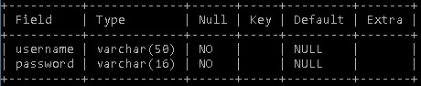

**Criminal Records :**

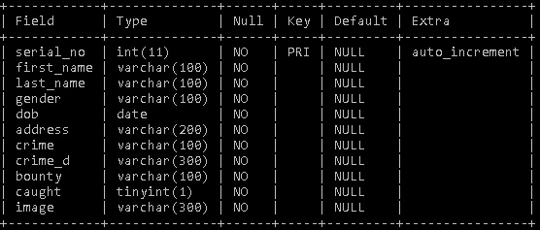

**Senior Citizen Records :**

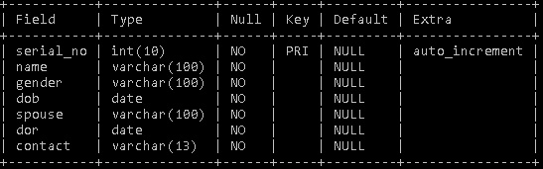

**Stolen Mobile Records:**

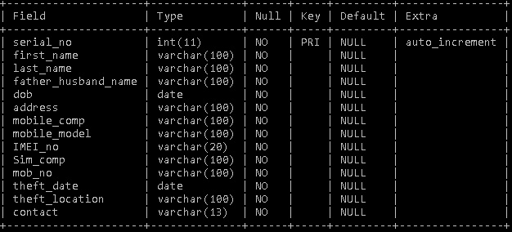

**Missing Person’s Records :**

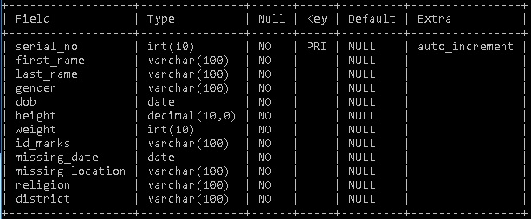

**Stolen Vehicle Records :**

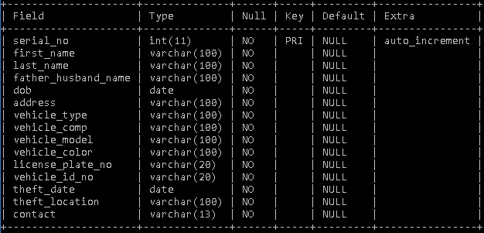

**SCREENSHOTS**

**Welcome Screen :**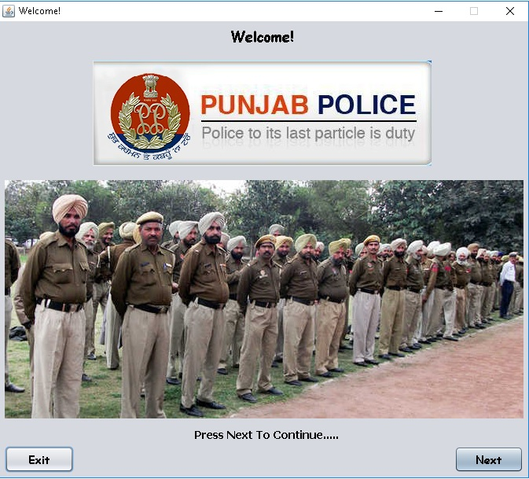

**Login Screen :**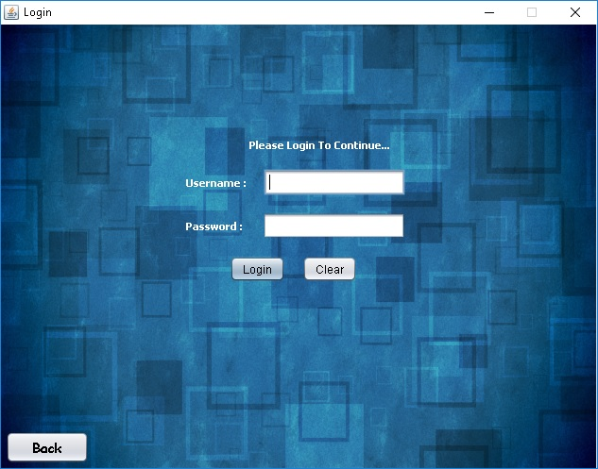

**Home Screen:**

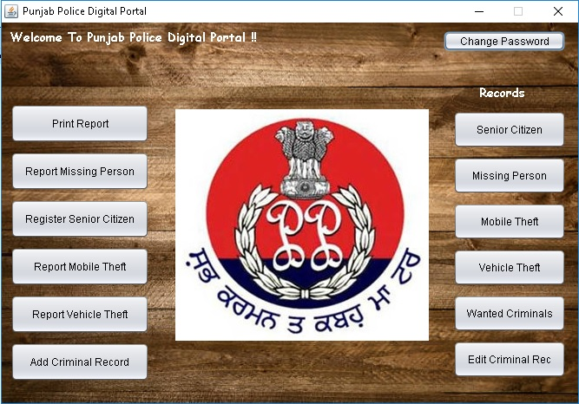

**Change Password :**

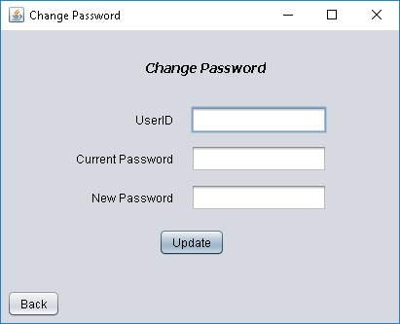

**Register Senior Citizen :**

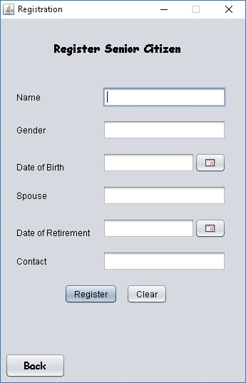

**Report Missing Person :**

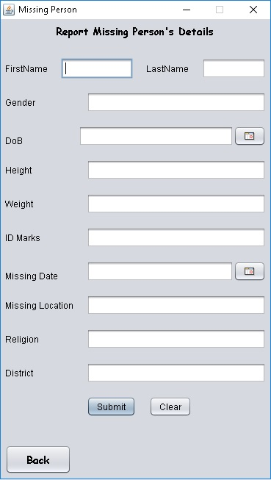

**Report Mobile Theft :**

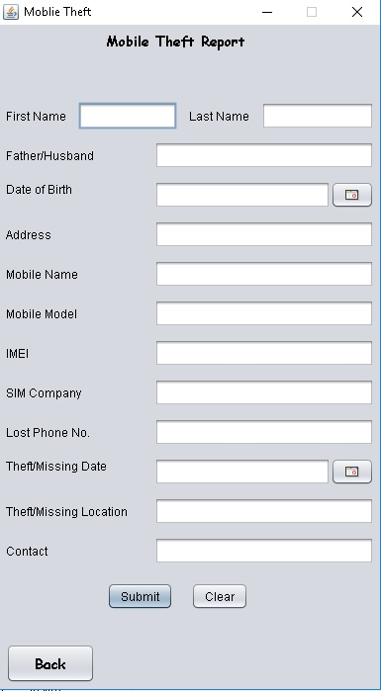

**Report Vehicle Theft :**

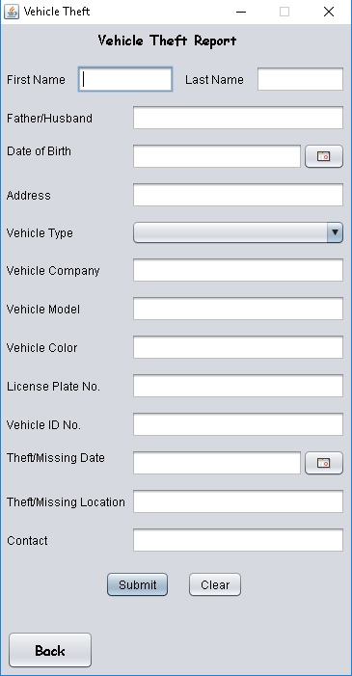

**Add Criminal Details :**

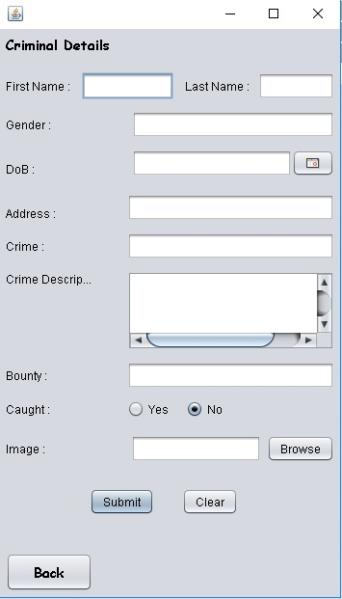

**View Records :**

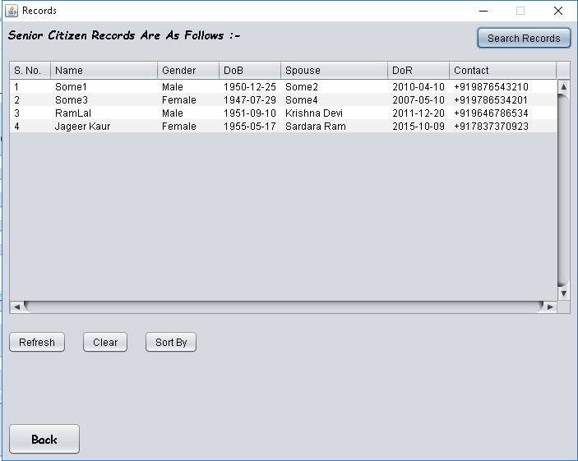

**Sort Records :**

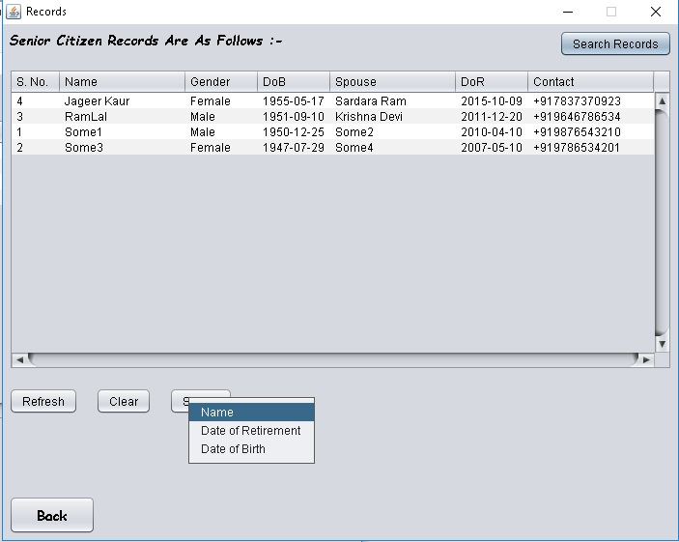

**Search Records :**

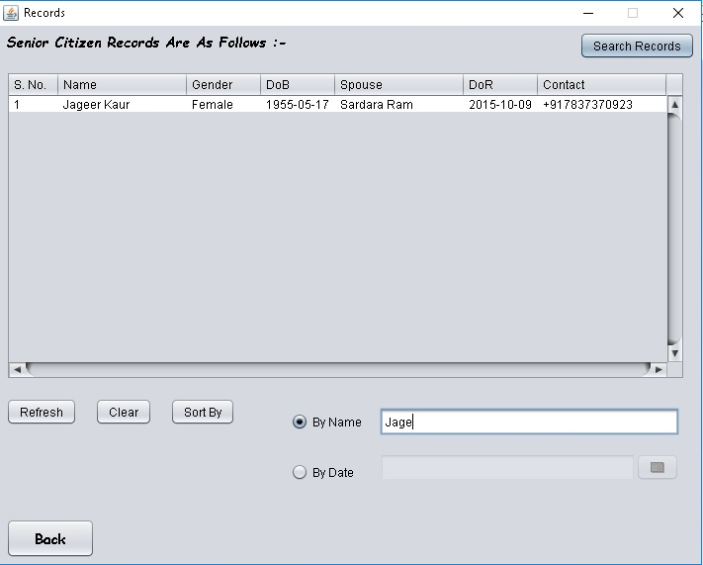

**Edit Criminal Record :**

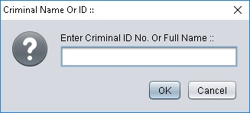

**Edit Criminal Record :**

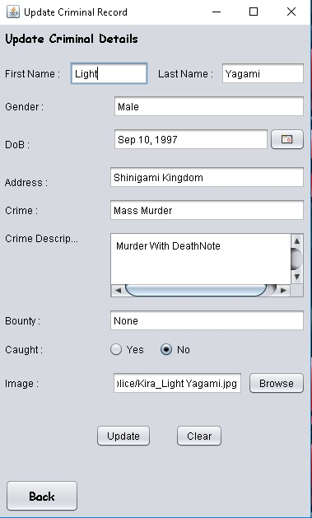

**Wanted Criminals:**

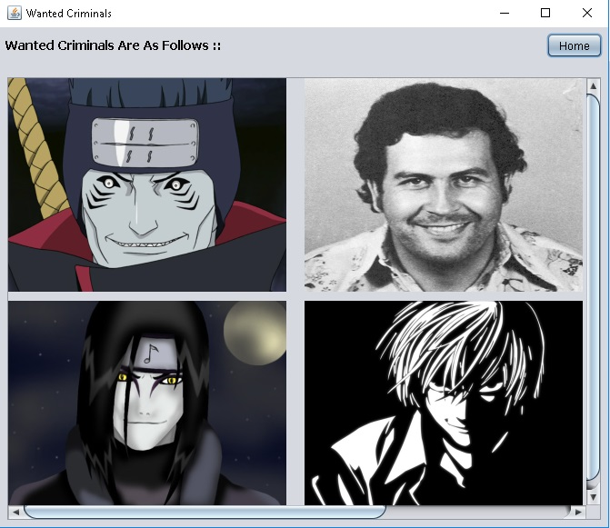

**Wanted Criminal Details :**

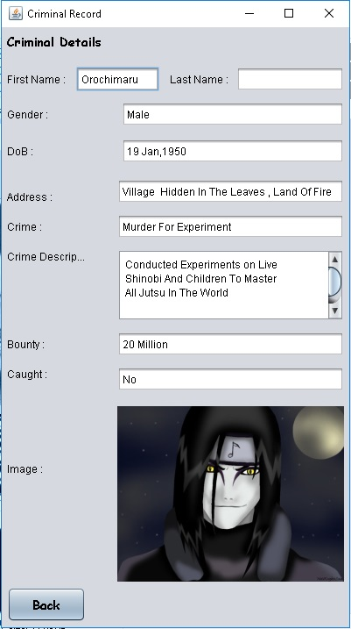

**Print Report:**

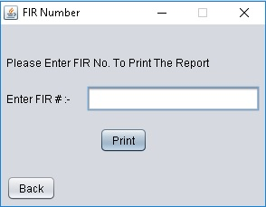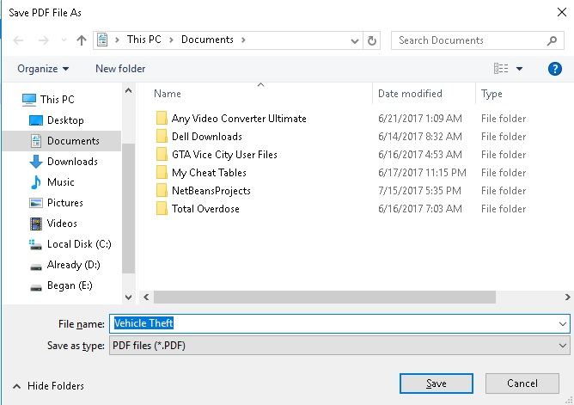

**CONCLUSION**

In the concluding section, it can be said that the proposed system is efficient enough against the given requirements, it is quite time-efficient, convenient to use, user friendly, consistent and provides enough security.

The system has been developed for the given condition and is found working effectively. The developed system is flexible and changes whenever can be made easy. Using the facilities and functionalities of java, the software has been developed in a neat and simple manner, thereby reducing the operators work.

The speed and accuracy are maintained in proper way. The user friendly nature of this software developed in java framework is very easy to work with both for the higher management as well as other people with little knowledge of computer. The results obtained were fully satisfactory from the user point of view.

What valued I have added to my knowledge.

SOLITAIRE INFOSYS working on various technologies. Also the individual responsibilities are more. So, we individually learn to work in team. Working on NetBeans and Java was a very enriching experience. It added to our list of knowhow and the computer languages known to us.

Some of these technologies were new to me and I am greatly thankful to my mam for her excellent teaching which greatly helped us.

**BIBLIOGRAPHY**

1. Google
2. <http://www.wikipedia.com>
3. A Textbook of Java (Library).